
(Flutter)
Flutter Lab 9

Total Time:
3 hours (session-1)

Pre-Lab Activities:
  - Basics of Flutter UI Widgets
  - Familiar with Development Coding Editor

Learning Outcomes:
  - Learn Flutter ListView.builder
  - Learn Flutter GridView.builder
  - Learn to work with Custom Objects
  - Learn to work with List

Student Activities:
  - Complete the pre-lab activities
  - Practicing Basic Widgets

Lab Tasks -9A:
- Design the UI accoriding to below given image.
- Develop a ListView of Custom Objects ( Doctor )

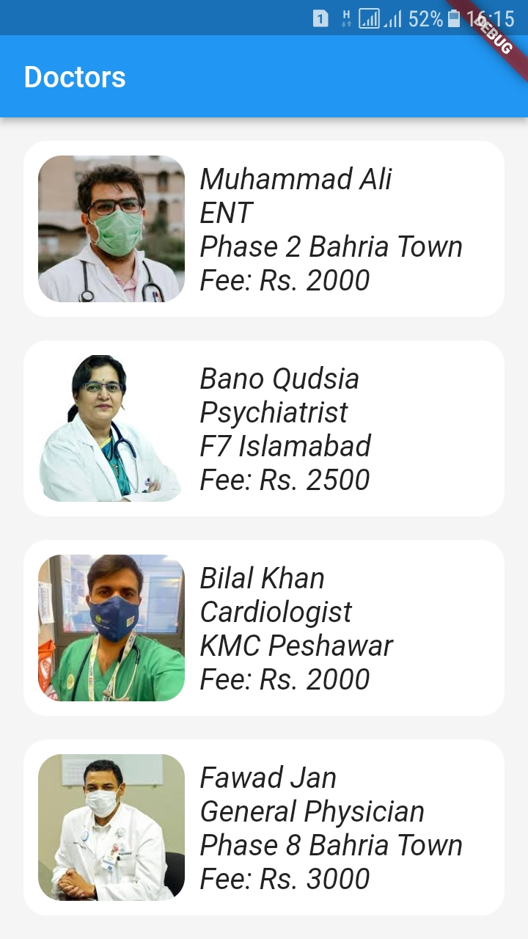

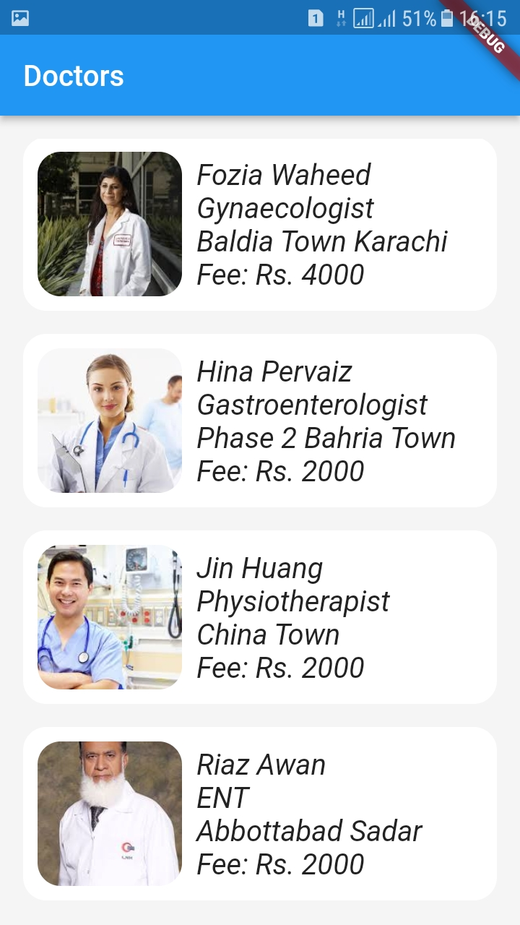

Lab Solutions:

LAB 9A :
CODE:

main.dart
import 'package:flutter/material.dart';
import 'package:listview_pseb_bridge_7a/screens/home_screen.dart';

void main() {
runApp(const MyApp());
}

class MyApp extends StatelessWidget {
const MyApp({Key? key}) : super(key: key);

// This widget is the root of your application.
@override
Widget build(BuildContext context) {
return MaterialApp(
title: 'Flutter Demo',
theme: ThemeData(

primarySwatch: Colors.blue,
),
home: const HomeScreen(),
);
}
}

Doctor.dart( Model class )
class Doctor {
final String name;
final String spe;
final String clinicAddress;
final int fee;
final String photo;

Doctor({
required this.name,
required this.spe,
required this.clinicAddress,
required this.fee,
required this.photo,
});
}

Data_store.dart
import '../models/doctor.dart';

class DataStore
{

static List<Doctor> doctors = [

Doctor(name: 'Muhammad Ali', spe: 'ENT', clinicAddress: 'Phase 2 Bahria Town', fee: 2000, photo: 'assets/images/ali.jpeg'),
Doctor(name: 'Bano Qudsia', spe: 'Psychiatrist', clinicAddress: 'F7 Islamabad', fee: 2500, photo: 'assets/images/bano.jpeg'),
Doctor(name: 'Bilal Khan', spe: 'Cardiologist', clinicAddress: 'KMC Peshawar', fee: 2000, photo: 'assets/images/bilal.jpeg'),
Doctor(name: 'Fawad Jan', spe: 'General Physician', clinicAddress: 'Phase 8 Bahria Town', fee: 3000, photo: 'assets/images/fawad.jpeg'),
Doctor(name: 'Fozia Waheed', spe: 'Gynaecologist', clinicAddress: 'Baldia Town Karachi', fee: 4000, photo: 'assets/images/fozia.jpeg'),
Doctor(name: 'Hina Pervaiz', spe: 'Gastroenterologist', clinicAddress: 'Phase 2 Bahria Town', fee: 2000, photo: 'assets/images/hina.jpeg'),
Doctor(name: 'Jin Huang', spe: 'Physiotherapist', clinicAddress: 'China Town', fee: 2000, photo: 'assets/images/jin.jpeg'),
Doctor(name: 'Riaz Awan', spe: 'ENT', clinicAddress: 'Abbottabad Sadar', fee: 2000, photo: 'assets/images/riaz.jpeg'),

];
}

Home_screen.dart
import 'package:flutter/material.dart';
import 'package:listview_pseb_bridge_7a/util/data_store.dart';

import '../models/doctor.dart';

class HomeScreen extends StatelessWidget {

const HomeScreen({Key? key}) : super(key: key);

@override
Widget build(BuildContext context) {
return Scaffold(
backgroundColor: Colors.grey[200],
appBar: AppBar(
title: const Text('Doctors'),
),
body: Padding(
padding: const EdgeInsets.all(16.0),
child: ListView.builder(
itemCount: DataStore.doctors.length,
itemBuilder: (context, index){

Doctor doctor = DataStore.doctors[index];

return Container(
padding: const EdgeInsets.all(10),
margin: const EdgeInsets.only(bottom: 16.0),
decoration: BoxDecoration(
color: Colors.white,
borderRadius: BorderRadius.circular(16.0),
),
child: Row(
children: [
ClipRRect(
borderRadius: BorderRadius.circular(16.0),
child: Image.asset(doctor.photo, width: 100, height: 100,
fit: BoxFit.cover,)),
const SizedBox(width: 10,),
Column(
crossAxisAlignment: CrossAxisAlignment.start,
children: [
Text(doctor.name, style: const TextStyle(fontSize: 20, fontStyle: FontStyle.italic),),
Text(doctor.spe, style: const TextStyle(fontSize: 20, fontStyle: FontStyle.italic),),
Text(doctor.clinicAddress, style: const TextStyle(fontSize: 20, fontStyle: FontStyle.italic),),
Text('Fee: Rs. ${doctor.fee}', style: const TextStyle(fontSize: 20, fontStyle: FontStyle.italic),),

],
)
],
),
);
}),
),
);
}
}

Complete source code:
https://github.com/abidroid/listview_pseb_bridge_7a
Note: Images can be found in the source code

Lab Tasks -9B:
- Design the UI accoriding to below given image.
- Develop a GridView of Custom Objects ( Doctor )

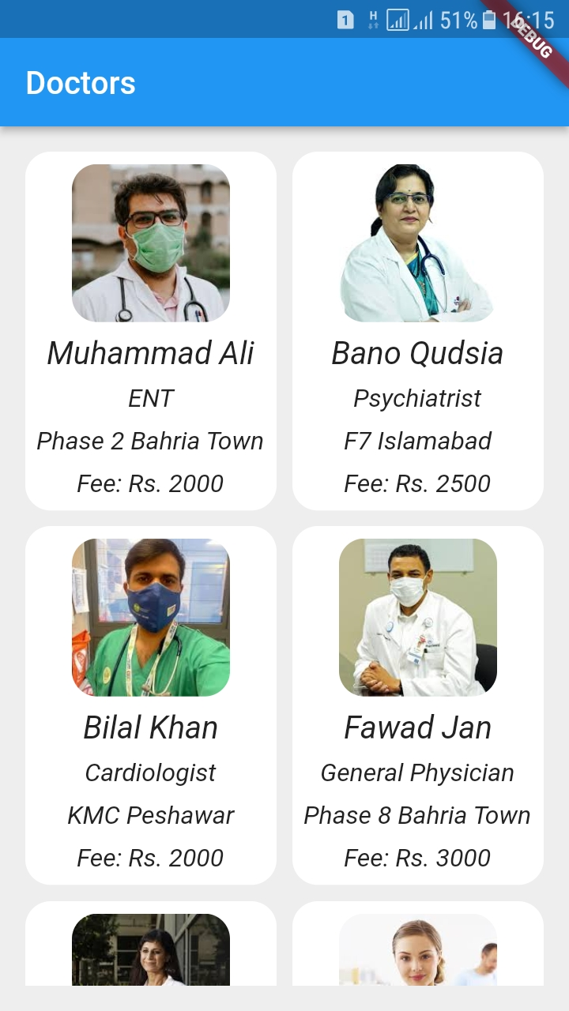

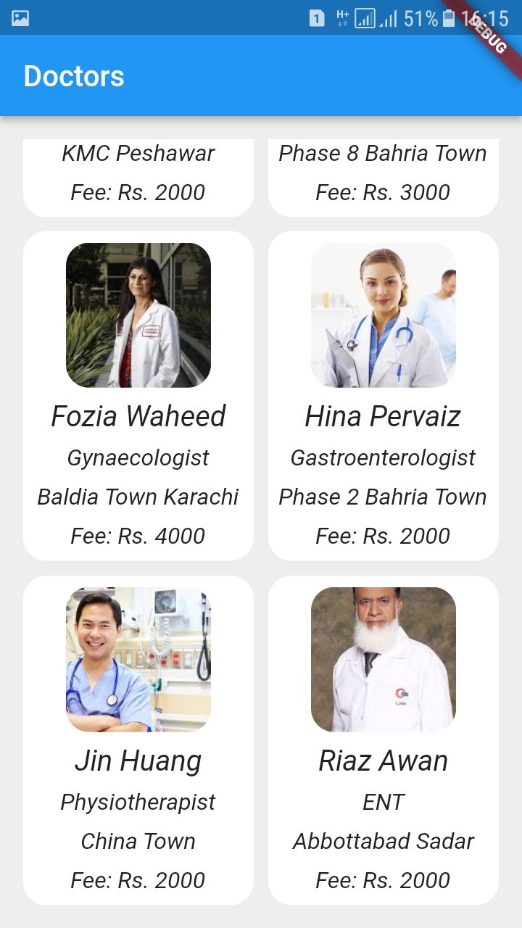

Lab 9B Solution ( Code )
Main.dart
import 'package:flutter/material.dart';
import 'package:gridview_pseb_bridge_7b/screens/home_screen.dart';

void main() {
runApp(const MyApp());
}

class MyApp extends StatelessWidget {
const MyApp({Key? key}) : super(key: key);

// This widget is the root of your application.
@override
Widget build(BuildContext context) {
return MaterialApp(
title: 'Flutter Demo',
theme: ThemeData(
primarySwatch: Colors.blue,
),
home: const HomeScreen(),
);
}
}

Doctor.dart( model class )
class Doctor {
final String name;
final String spe;
final String clinicAddress;
final int fee;
final String photo;

Doctor({
required this.name,
required this.spe,
required this.clinicAddress,
required this.fee,
required this.photo,
});
}

Data_store.dart
import '../models/doctor.dart';

class DataStore
{

static List<Doctor> doctors = [

Doctor(name: 'Muhammad Ali', spe: 'ENT', clinicAddress: 'Phase 2 Bahria Town', fee: 2000, photo: 'assets/images/ali.jpeg'),
Doctor(name: 'Bano Qudsia', spe: 'Psychiatrist', clinicAddress: 'F7 Islamabad', fee: 2500, photo: 'assets/images/bano.jpeg'),
Doctor(name: 'Bilal Khan', spe: 'Cardiologist', clinicAddress: 'KMC Peshawar', fee: 2000, photo: 'assets/images/bilal.jpeg'),
Doctor(name: 'Fawad Jan', spe: 'General Physician', clinicAddress: 'Phase 8 Bahria Town', fee: 3000, photo: 'assets/images/fawad.jpeg'),
Doctor(name: 'Fozia Waheed', spe: 'Gynaecologist', clinicAddress: 'Baldia Town Karachi', fee: 4000, photo: 'assets/images/fozia.jpeg'),
Doctor(name: 'Hina Pervaiz', spe: 'Gastroenterologist', clinicAddress: 'Phase 2 Bahria Town', fee: 2000, photo: 'assets/images/hina.jpeg'),
Doctor(name: 'Jin Huang', spe: 'Physiotherapist', clinicAddress: 'China Town', fee: 2000, photo: 'assets/images/jin.jpeg'),
Doctor(name: 'Riaz Awan', spe: 'ENT', clinicAddress: 'Abbottabad Sadar', fee: 2000, photo: 'assets/images/riaz.jpeg'),

];
}

Home_screen.dart
import 'package:flutter/material.dart';

import '../models/doctor.dart';
import '../utils/data_store.dart';

class HomeScreen extends StatelessWidget {

const HomeScreen({Key? key}) : super(key: key);

@override
Widget build(BuildContext context) {
return Scaffold(
backgroundColor: Colors.grey[200],
appBar: AppBar(
title: const Text('Doctors'),
),
body: Padding(
padding: const EdgeInsets.all(16.0),
child: GridView.builder(
gridDelegate: const SliverGridDelegateWithFixedCrossAxisCount(
crossAxisCount: 2,
crossAxisSpacing: 10,
mainAxisSpacing: 10,
childAspectRatio: 7/10
),
itemCount: DataStore.doctors.length,
itemBuilder: (context, index){

Doctor doctor = DataStore.doctors[index];
return Container(

decoration: BoxDecoration(
color: Colors.white,
borderRadius: BorderRadius.circular(16.0),
),
child: Column(
mainAxisAlignment: MainAxisAlignment.spaceEvenly,
children: [
ClipRRect(
borderRadius: BorderRadius.circular(16.0),
child: Image.asset(doctor.photo, width: 100, height: 100,
fit: BoxFit.cover,)),
Text(doctor.name, style: const TextStyle(fontSize: 20, fontStyle: FontStyle.italic),),
Text(doctor.spe, style: const TextStyle(fontSize: 16, fontStyle: FontStyle.italic),),
Text(doctor.clinicAddress, style: const TextStyle(fontSize: 16, fontStyle: FontStyle.italic),),
Text('Fee: Rs. ${doctor.fee}', style: const TextStyle(fontSize: 16, fontStyle: FontStyle.italic),)
],
),
);

}),
),
);
}
}

Complete source code:
https://github.com/abidroid/gridview_pseb_bridge_7b

